**Object In Java**

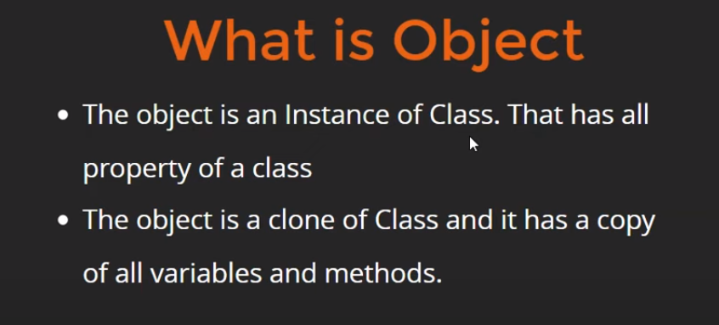

**Example:**

public class Main {

// main Method

public static void main(String[] args) {

// Student is the type of std Object

Student std = new Student();

// Returning value;

System.out.println(std.getName());

// Displaying Name

std.displayName();

// Teacher Object

Teacher tch = new Teacher();

String teachName = "Archee Shree";

tch.displayName(teachName);

}

}

class Student {

int defaultAge = 18;

public String getName() {

return "Chandan Kumar";

}

void displayName() {

System.out.println("My name is Kumar");

}

}

class Teacher {

void displayName(String techNam){

System.out.println(techNam);

}

}

**Output:**

Chandan Kumar  
My name is kumar  
Archee Shree